**Practical 2**

**Creating account, repository on Github and Cloning repository in Github.**

1. **Creating Account:**

**Step 1:** Go to [**https://github.com/join**](https://github.com/join)in a web browser. You can use any web browser on your computer, phone or tablet to join.

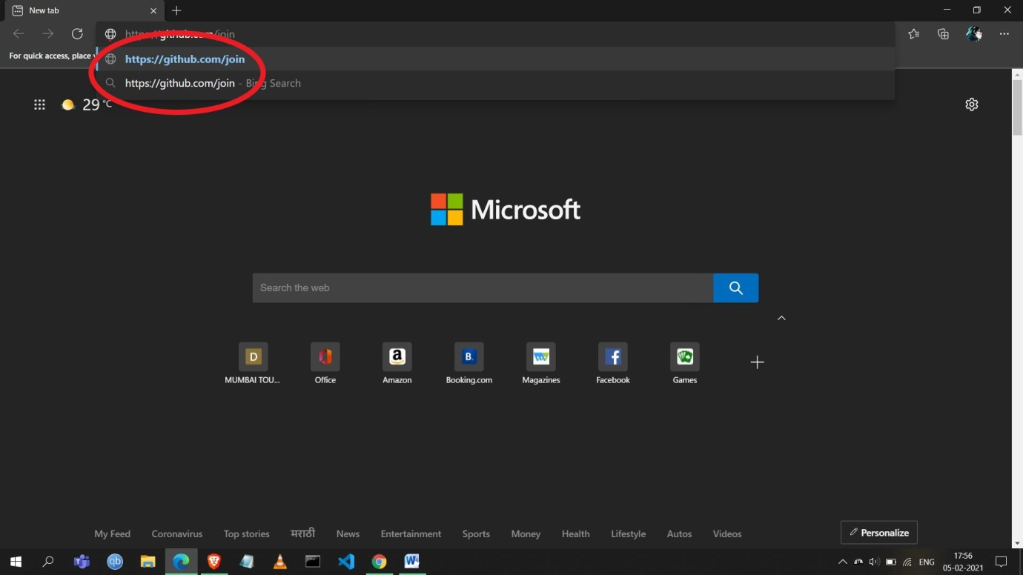

**Step 2:** Enter your personal details and complete the CAPTCHA puzzle.

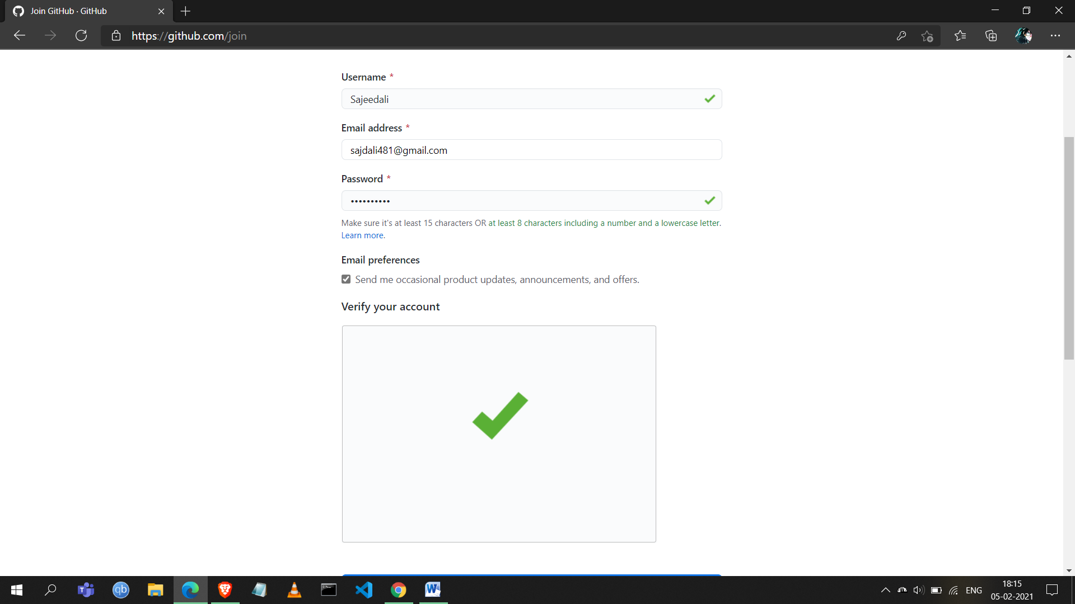

**Step 3:** Click the **‘Create account’** button below the form.

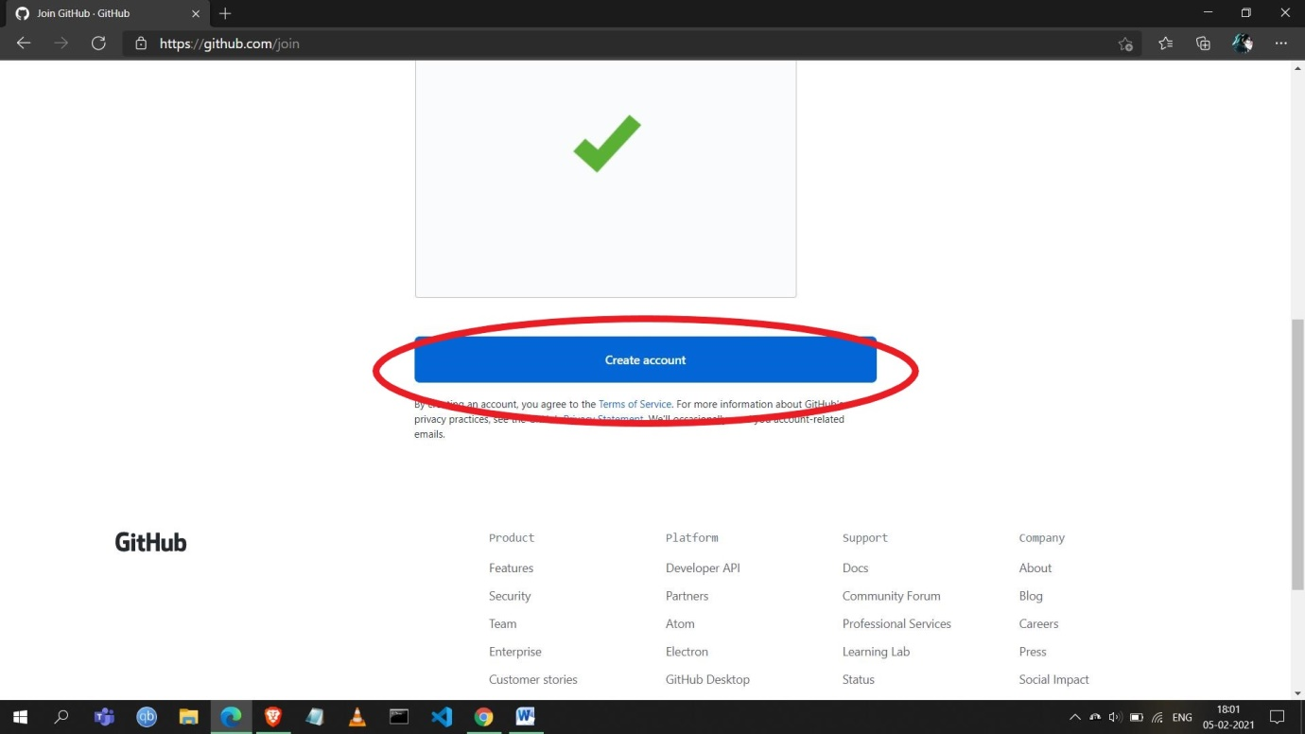

**Step 4:** Select your preferences and click on **‘Complete Setup’.**

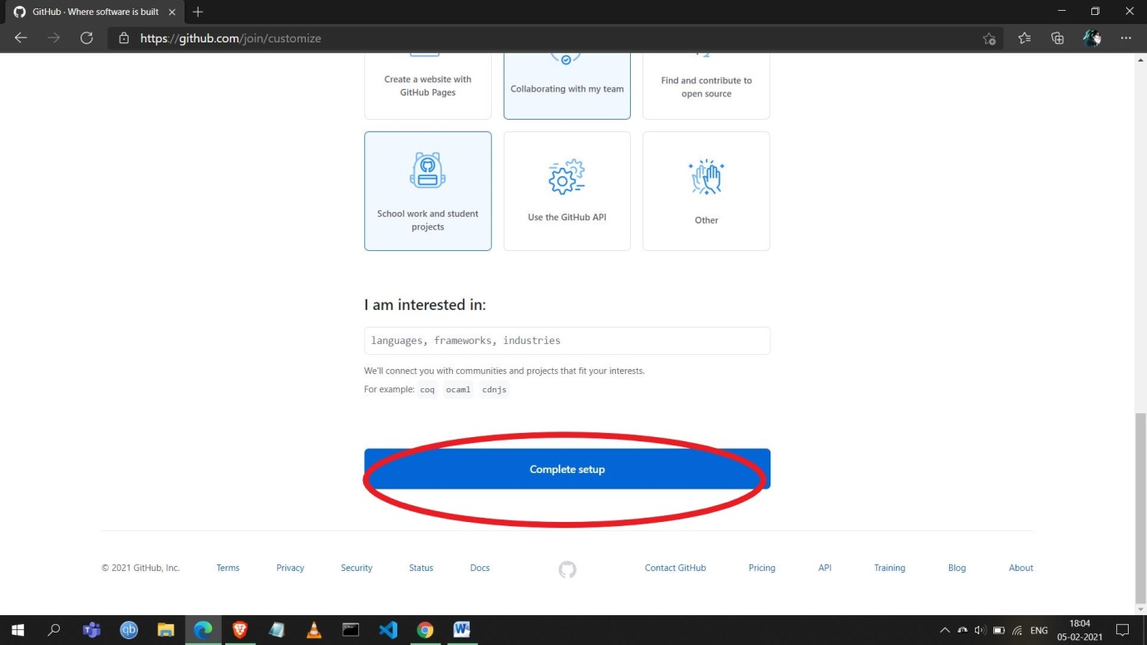

**Step 5:** Verify your email. This confirms your email address and returns you to sign up process.

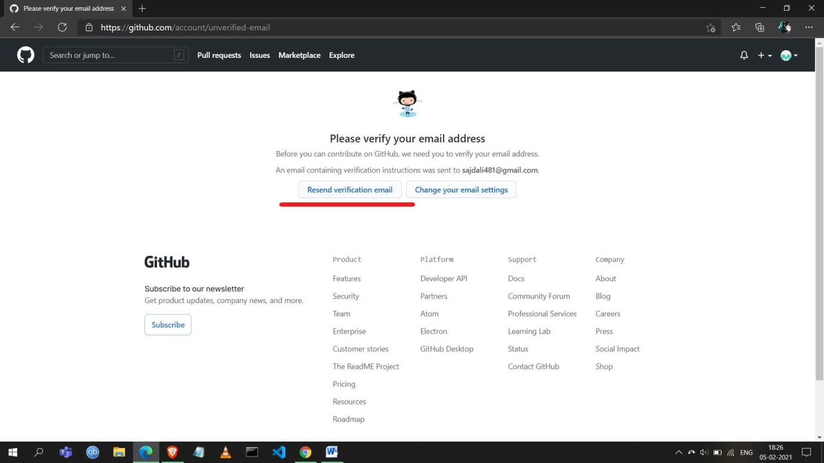

**Step 6:** After the email verification the account will be created. The below page will appear once the account is created.

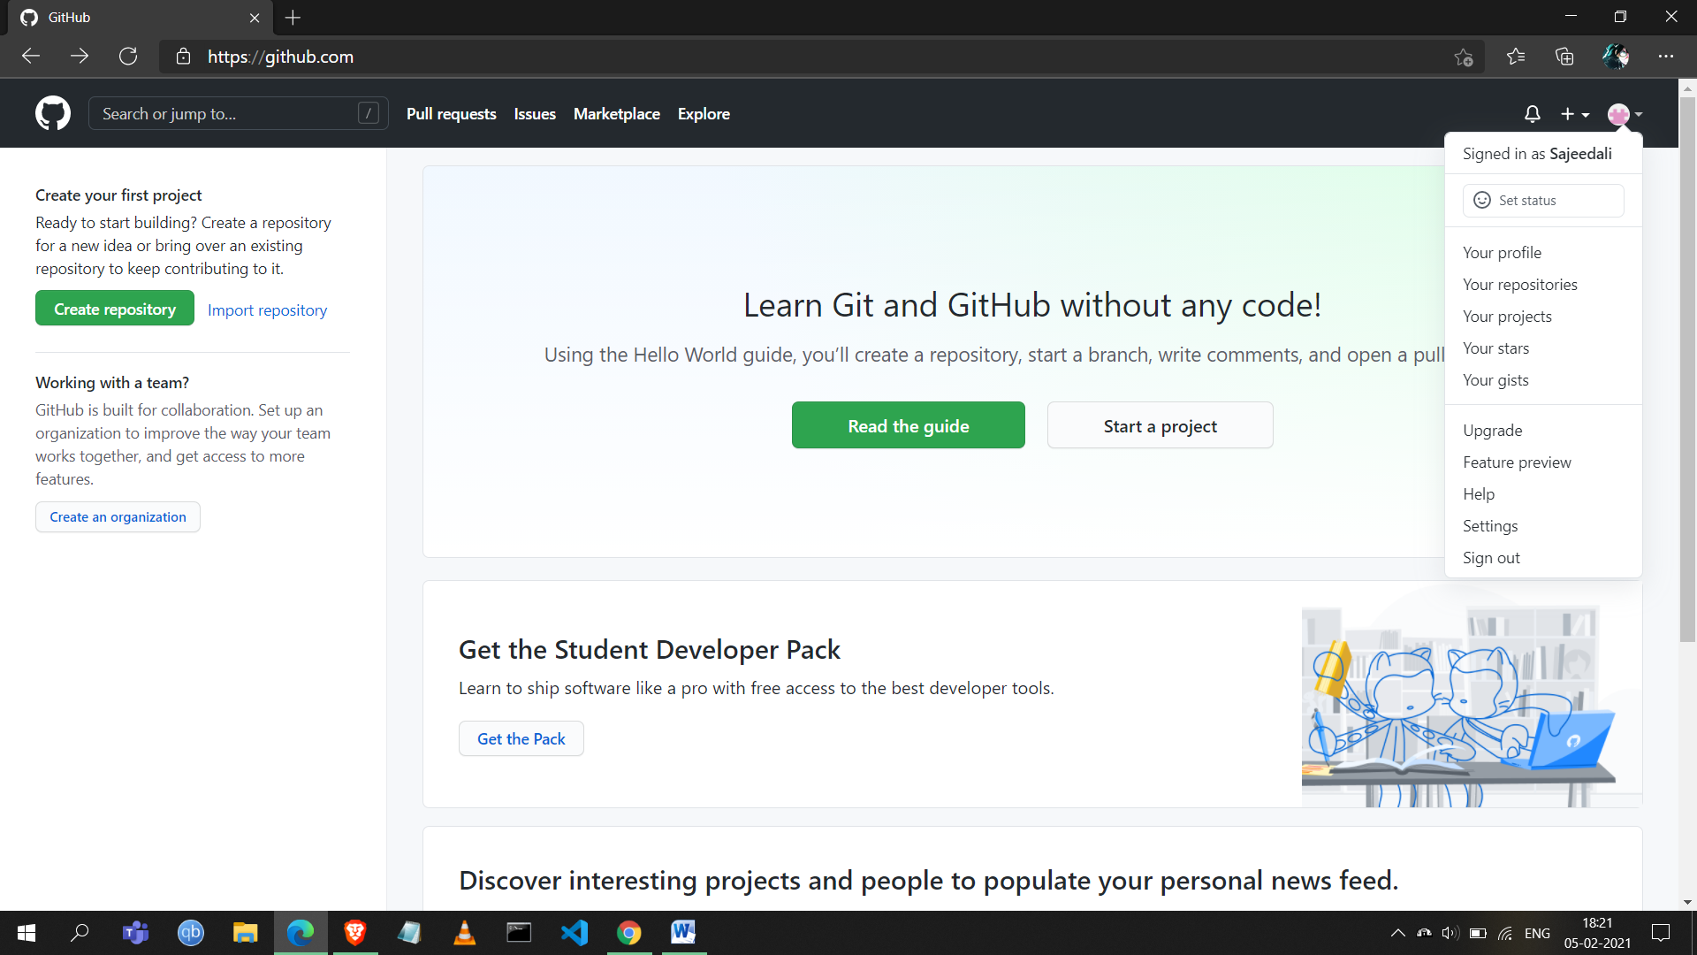

1. **Creating Repository:**

**Step 1:** Click on the **‘Create Repository’** button given on the left side.

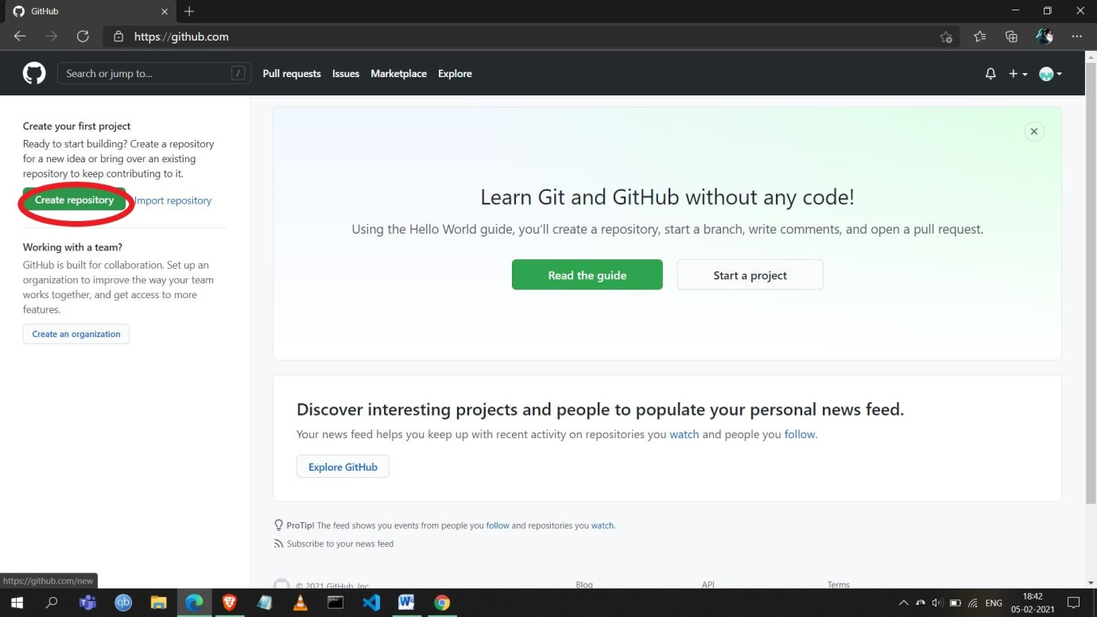

**Step 2:** Fill the details and click on the **‘Create repository’** button below.

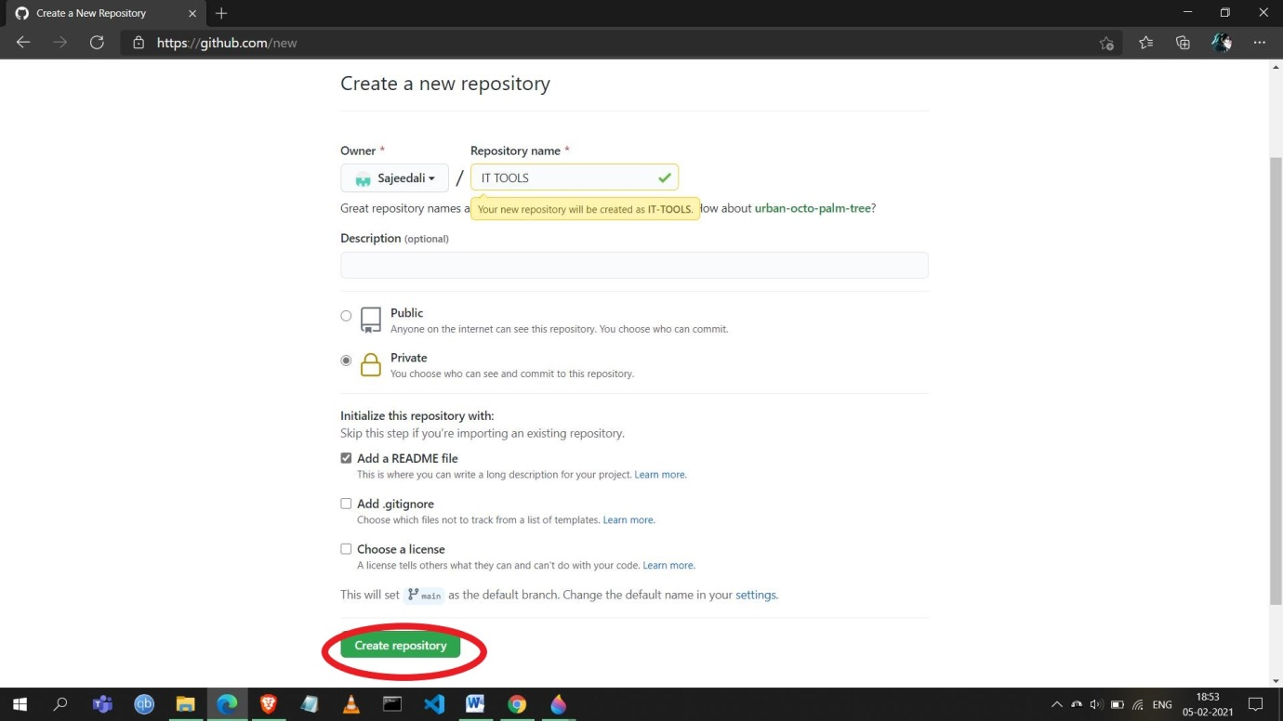

**Step 3:** You can also create or upload files in your repository from your system as given below.

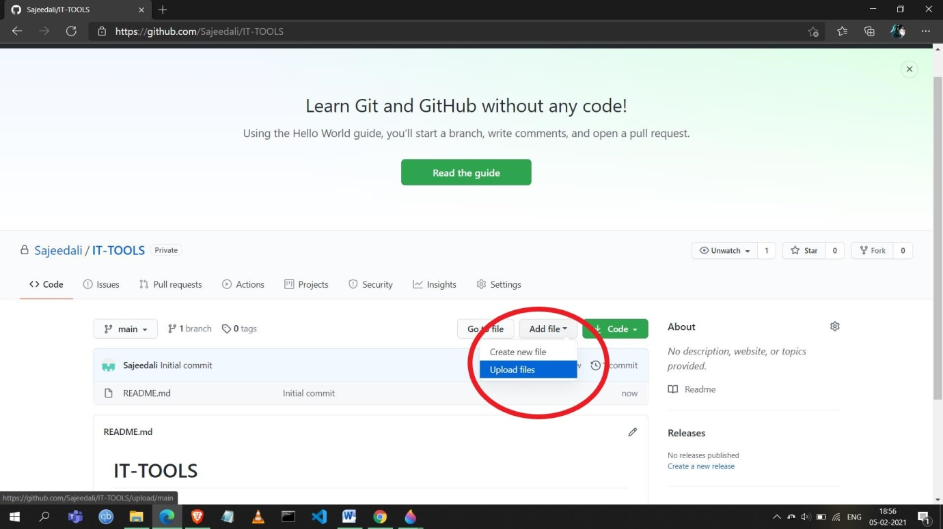

**Step 4:** After uploading files click on the **‘Commit changes’** button.

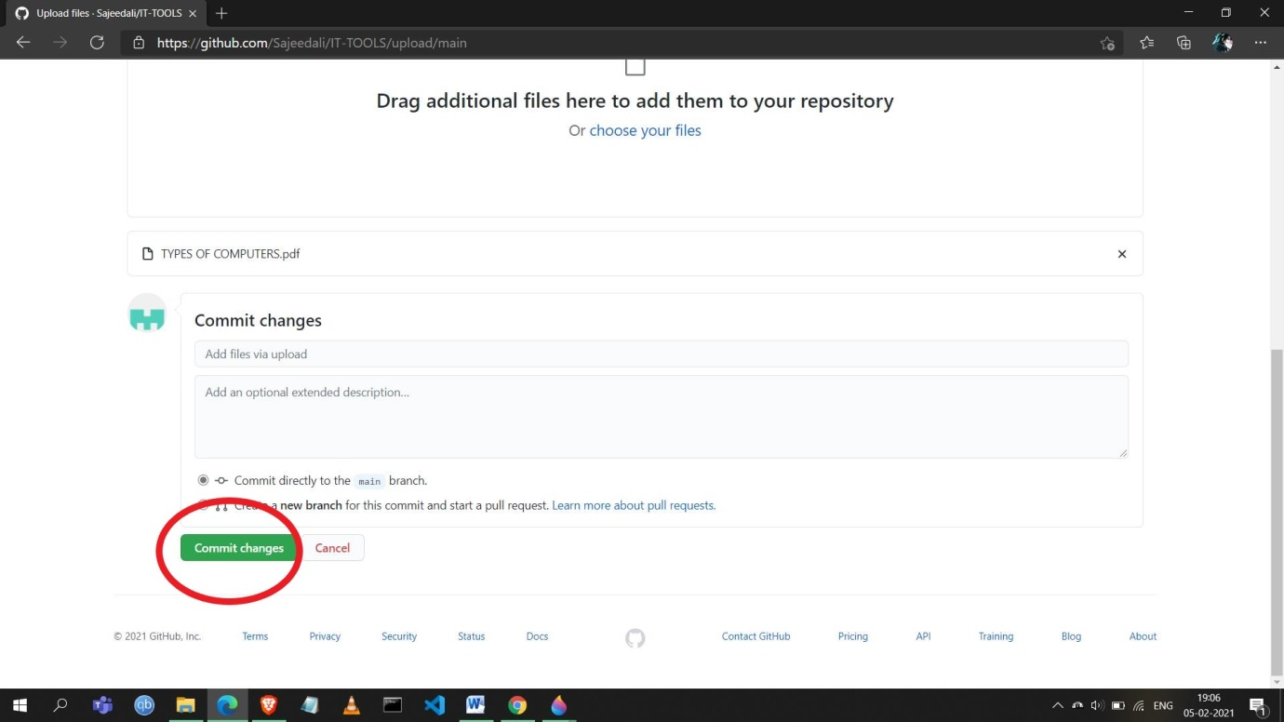

**Step 4:** Now the repository has been created as you can see below.

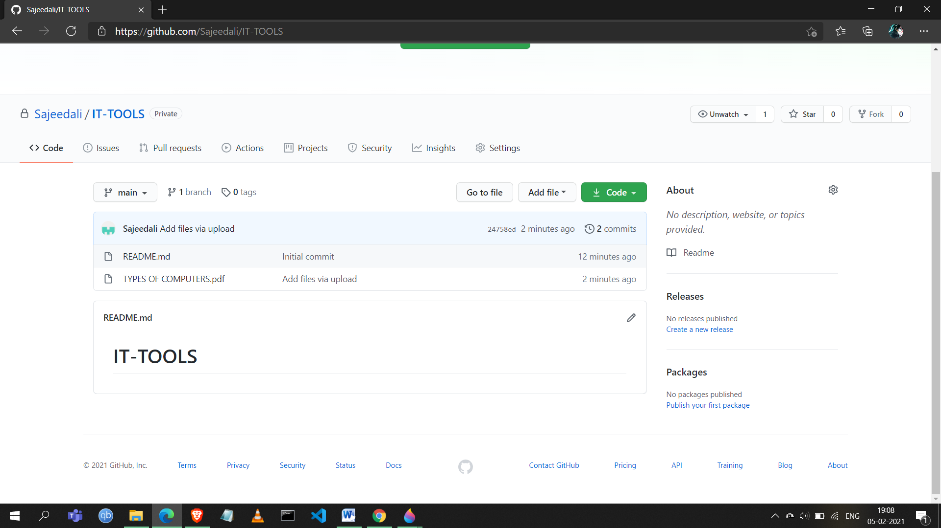

1. **Cloning Repository:**

**Step 1:** Click on the **‘Code’** button as mentioned below.

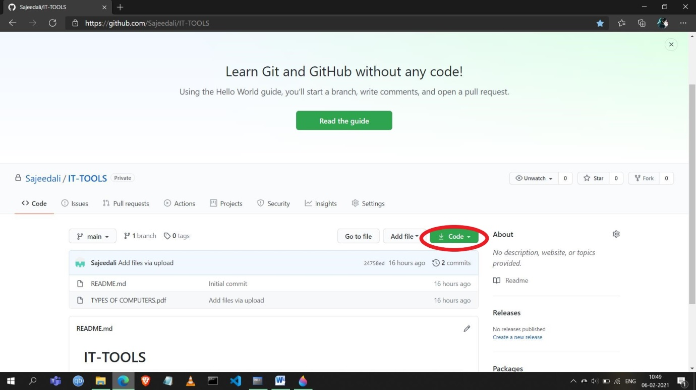

**Step 2: Click on the clipboard icon as mentioned to copy the url. It will create a clone of your repository.**

